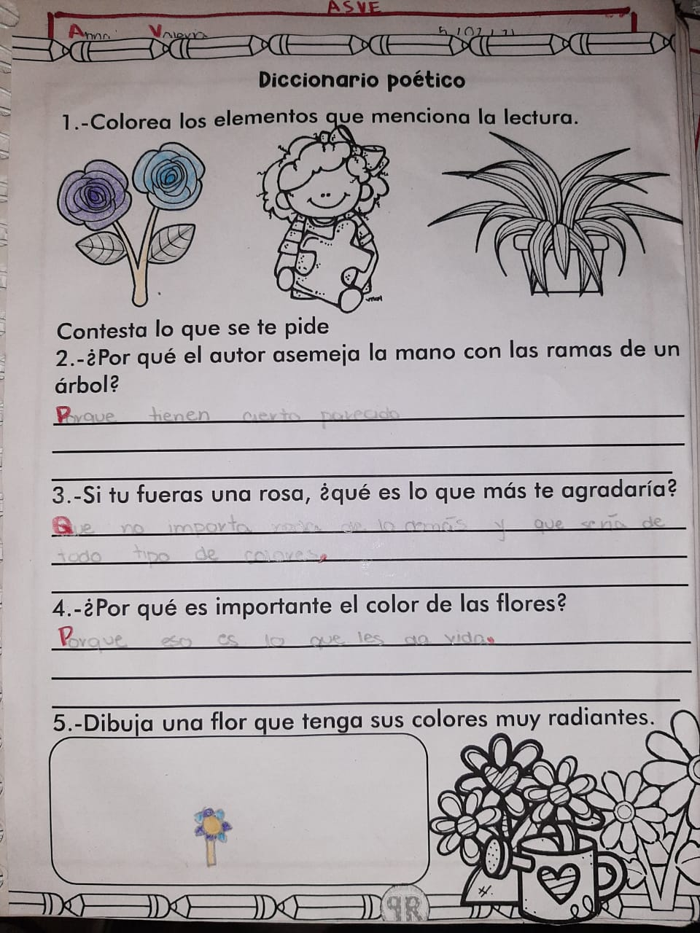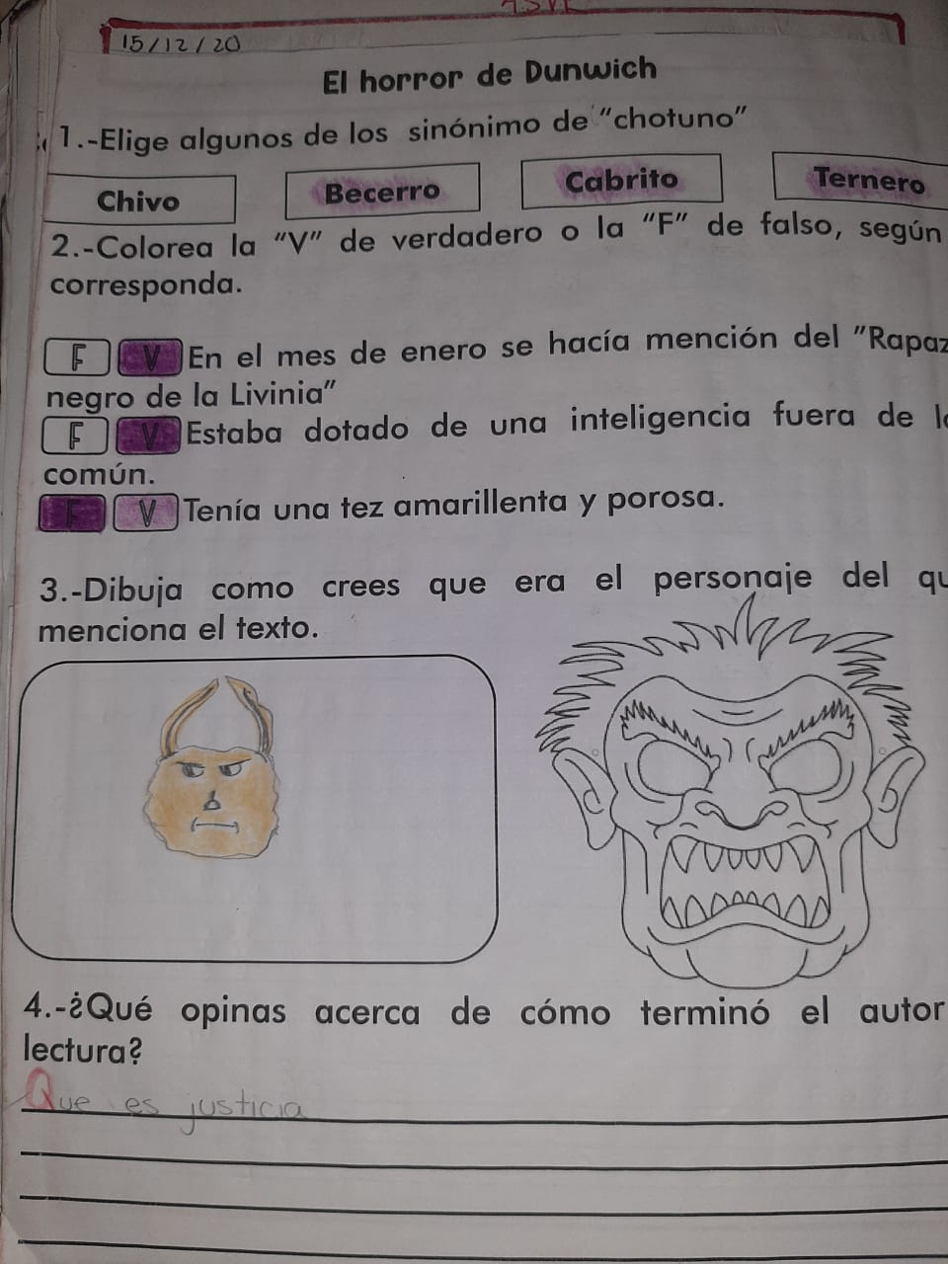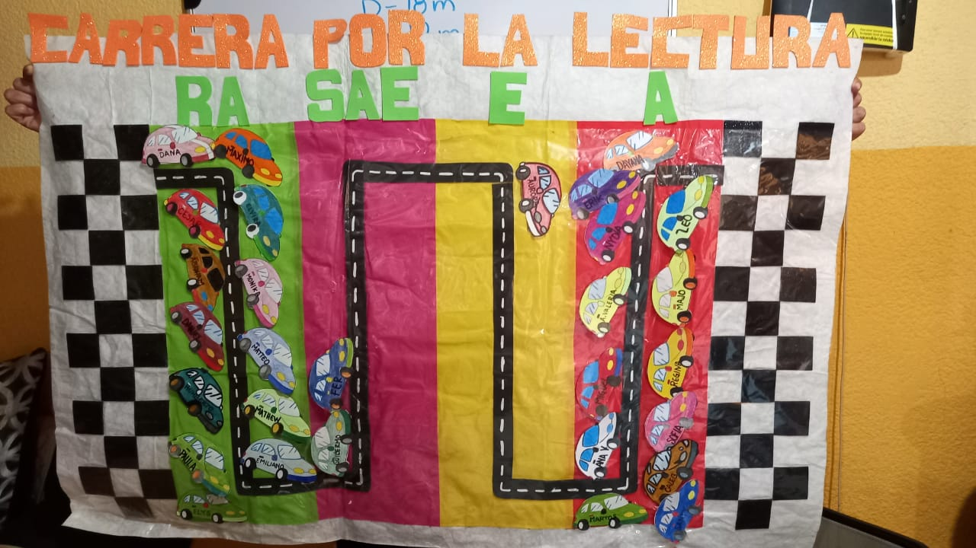 REGISTRÓ DE VELOCIDAD LECTORA

|  |  |  |  |  |  |
| --- | --- | --- | --- | --- | --- |
| ALUNO (A) | TOMA 1 | TOMA 2 | TOMA 3 | TOMA 4 | TOTAL |
| SOFIA | 177 A |  |  |  |  |
| MARIA PAULA | 82 RA |  |  |  |  |
| DAYANA | 221 A |  |  |  |  |
| FERNANDA | 109 SAE |  |  |  |  |
| ANA VICTORIA | 154 A |  |  |  |  |
| ERIK DE JESUS | 173 A |  |  |  |  |
| DANIEL G. | 87 RA |  |  |  |  |
| MATHEW A. | 96 RA |  |  |  |  |
| NYDIA | 199 A |  |  |  |  |
| MAXIMO | 67 RA |  |  |  |  |
| MIGUEL A. | 112 SAE |  |  |  |  |
| HUMERTO A. | 87 RA |  |  |  |  |
| LEONARDO | 156 A |  |  |  |  |
| AURORA G. | 123 E |  |  |  |  |
| VALERIA F. | 154 A |  |  |  |  |
| MA. REGINA | 167 A |  |  |  |  |
| CALEB | 172 A |  |  |  |  |
| CESAR N. | 98 RA |  |  |  |  |
| EMILIANO | 96 RA |  |  |  |  |
| ELYS REGINA | 87 RA |  |  |  |  |
| GUILLERMO | 101 SAE |  |  |  |  |
| MATTEO | 76 RA |  |  |  |  |
| MARIA JOSE | 187 A |  |  |  |  |
| DANNA V. | 65 RA |  |  |  |  |
| MONIKA | 68 RA |  |  |  |  |
| ANA VALERIA | 200 A |  |  |  |  |
| SANTIAGO | 134 A |  |  |  |  |
| ABRAHAM | 79 RA |  |  |  |  |
| ELVIRA | 68 RA |  |  |  |  |

Toma 1: LECTURA EL HORROR DE DUNWISH, día 28 de enero

Toma 2:

Toma 3:

Toma 4:

Toma 5: